Smart Drunk Driving Detection System with Entry Gate – Arduino Project Report

Executive Summary
The Smart Drunk Driving Detection System with Entry Gate is an innovative embedded systems project designed to enhance road safety through real-time alcohol detection and automated gate control. This system employs an Arduino Uno microcontroller combined with an MQ3 alcohol sensor to detect alcohol vapor in a driver's breath and automatically blocks vehicle access through a servo-controlled gate mechanism if intoxication levels exceed permissible thresholds. The project integrates multiple components including an LCD display for real-time status visualization and a buzzer for audible alerts, making it an effective demonstration of IoT-based safety applications for parking checkpoints, residential complexes, and road safety awareness programs.​

Project Overview and Objectives

Purpose and Applications
This project addresses one of the most critical road safety challenges: drunk driving prevention. The system prevents intoxicated individuals from accessing vehicles by implementing an automated checkpoint system that combines detection and physical access control. The primary objectives include:​
Safety Enhancement: Preventing drunk drivers from operating vehicles by detecting alcohol vapor through breath analysis.
Automated Access Control: Using servo motor-controlled gates to physically block entry for individuals with alcohol levels exceeding safe thresholds.
Real-time Status Monitoring: Providing immediate visual feedback through the LCD display showing sobriety status.
Audible Alerting: Using a buzzer to provide audio warnings when alcohol is detected above permissible levels.

Ideal Applications
- The system is suitable for deployment in various scenarios:​
- College and school parking lots for student safety awareness
- Residential complex access gates with automated sobriety checkpoints
- Corporate parking facilities emphasizing employee safety
- Road safety demonstration units at police checkpoints or traffic control centers
- Parking garage entry systems
- Ride-sharing vehicle dispatch stations

Hardware Components and Specifications

Component Specifications
Arduino Uno Microcontroller​
The Arduino Uno serves as the central processing unit for the entire system. Based on the ATmega328P 8-bit AVR microcontroller, it features:
- Operating Voltage: 5V DC
- Analog Input Pins: 6 (A0–A5)
- Digital I/O Pins: 14 (6 with PWM capability)
- Clock Speed: 16 MHz
- Flash Memory: 32 KB
- SRAM: 2 KB
- Power Options: USB or 7-12V external power
The Arduino Uno's reliability, ease of programming, and extensive peripheral support make it ideal for prototype development and educational projects.
MQ3 Alcohol Sensor​
The MQ3 is a semiconductor gas sensor designed specifically for alcohol vapor detection:
- Sensing Element: Tin dioxide (SnO₂)
- Operating Voltage: 5V DC
- Sensor Principle: Resistance changes in SnO₂ when exposed to alcohol vapor
- Detection Range: 300–10,000 ppm (parts per million)
- Response Time: Less than 10 seconds for rapid detection
- Operating Temperature Range: -10°C to 50°C
- Output Type: Dual output (analog 0–5V and digital TTL)
- Warm-up Time: 24–48 hours recommended before accurate readings
- Sensitivity: High sensitivity specifically to alcohol vapors
The sensor converts alcohol concentration into a proportional analog voltage that the Arduino can read and compare against threshold values.​
Servo Motor (SG90)​
The servo motor provides precise control over the gate mechanism:
- Type: Standard servo motor (SG90 typical model)
- Rotation Range: 0° to 180°
- Control Method: Pulse Width Modulation (PWM)
- Operating Voltage: 5V
- Torque: Sufficient for light gate mechanisms
- Pulse Width Mapping:
  - 1 ms pulse = 0° position (gate fully open)
  - 1.5 ms pulse = 90° position (gate neutral/partially open)
  - 2 ms pulse = 180° position (gate fully closed)
- Response Time: Fast positioning with feedback control
16x2 LCD Display with I2C Module​
The LCD provides visual status information to users:
- Display Format: 16 characters × 2 lines
- Communication: I2C (Inter-Integrated Circuit) protocol
- I2C Address: 0x27 or 0x3F (depending on module)
- Connection Pins: SDA (A4), SCL (A5) on Arduino
- Operating Voltage: 5V
- Typical Functions: Display sobriety status, alcohol level readings, system messages
Buzzer
The buzzer provides immediate audio feedback:
- Operating Voltage: 5V
- Connection: Digital output pin (typically pin 8)
- Function: Activates when alcohol detection exceeds threshold
- Output: Continuous beep pattern for alert
Power Supply
- Voltage: 5V DC regulated supply
- Current Requirement: 500 mA – 1A (depending on servo torque and total load)
- Sources: USB connection, 5V power adapter, or battery with voltage regulator

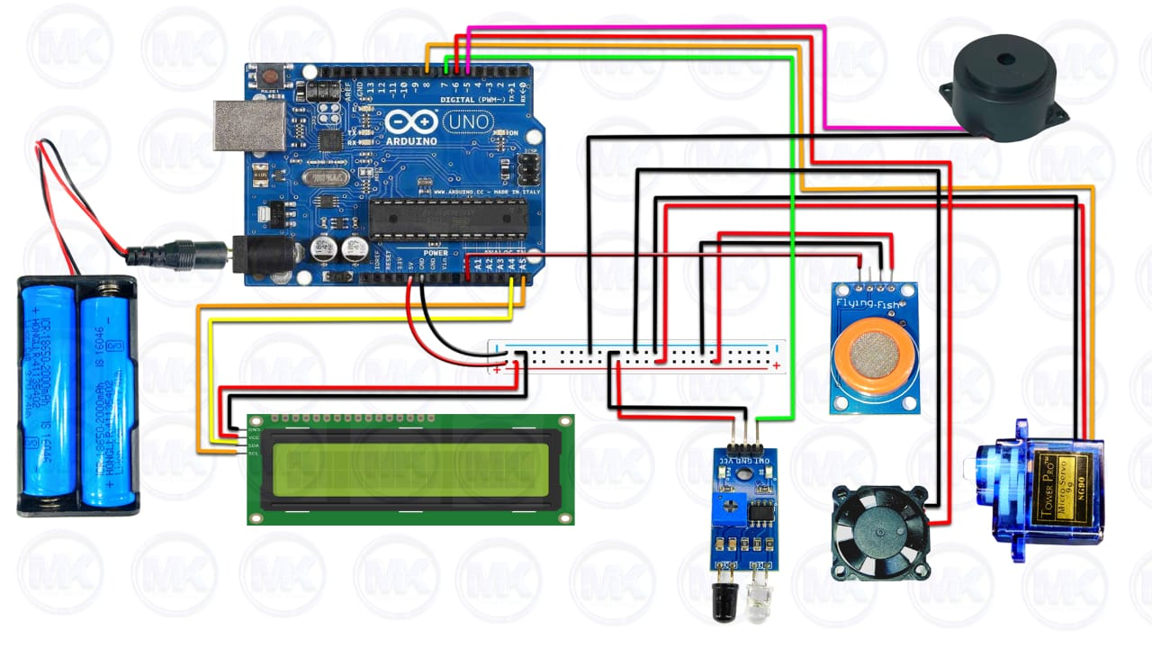
System Architecture

Working Principle and System Operation

Detection Process
The system operates through a continuous feedback loop that monitors alcohol levels in real time:​
Breath Sampling: When a driver approaches the checkpoint, they breathe into or near the MQ3 sensor. The sensor is positioned to capture breath vapor, typically mounted at eye level or in a breath capture chamber.
Analog Signal Conversion: The MQ3 sensor's tin dioxide element undergoes electrical resistance changes proportional to alcohol vapor concentration. This resistance change is converted to an analog voltage signal (0–5V) by the sensor's internal circuitry.​
Arduino Processing: The Arduino Uno continuously reads the analog signal via pin A0 at regular intervals. The analog value is converted to a digital representation (0–1023 on the 10-bit ADC) and compared against programmed threshold values.​
Threshold Comparison: The Arduino evaluates the sensor reading against calibrated thresholds:​
Decision and Response: Based on the comparison, the Arduino executes different control sequences for the servo motor, LCD display, and buzzer.
The exact threshold values can be calibrated based on specific sensor modules and requirements.

Arduino Code Structure and Implementation
#include <Servo.h>
#include <LiquidCrystal_I2C.h>
#define buzzer 5
#define fan 6
#define proximity_sensor 7
#define alcohol_sensor A0

Servo myservo;

LiquidCrystal_I2C lcd(0x27, 16, 2);
int pos = 0;
int alcohol_value;
int check = 0;
bool prox;
unsigned long previousMillis = 0;
int screenState = 0;

void setup() {
Serial.begin(9600);

myservo.attach(8);
myservo.write(53);
pinMode(fan, OUTPUT);
pinMode(buzzer, OUTPUT);
pinMode(proximity_sensor, INPUT);

digitalWrite(fan, LOW);
lcd.init();
lcd.backlight();
lcd.clear();
}

void loop() {
unsigned long currentMillis = millis();
if (currentMillis - previousMillis >= 2500) {
previousMillis = currentMillis;
lcd.clear();
if (screenState == 0) {
lcd.setCursor(0, 0);
lcd.print(" REAL TIME ");
lcd.setCursor(0, 1);
lcd.print("DRUNK AND DRIVE");
screenState = 1;
} else if (screenState == 1) {
lcd.setCursor(0, 0);
lcd.print(" TEST SYSTEM ");
lcd.setCursor(0, 1);
lcd.print(" WITH ENTRY ");
screenState = 2;
} else if (screenState == 2) {
lcd.setCursor(0, 0);
lcd.print(" RESTRICTION ");
lcd.setCursor(0, 1);
lcd.print(" USING ARDUINO ");
screenState = 0;

} else {
screenState = 0;
}
}

prox = !digitalRead(proximity_sensor);
while (prox == true and check <= 50) {
prox = !digitalRead(proximity_sensor);
check++;
delay(10);
}
if (check >= 50) {
check = 0;

lcd.clear();
lcd.setCursor(0, 0);
lcd.print("VEHICLE DETECTED");
Serial.println("VEHICLE DETECTED");
delay(1500);
lcd.setCursor(0, 1);
lcd.print("TESTING ALCOHOL");
Serial.println("TESTING ALCOHOL");
delay(2000);

lcd.clear();
lcd.setCursor(0, 0);
lcd.print("VALUE: ");
lcd.setCursor(0, 1);
lcd.print("TIME: ");
digitalWrite(fan, HIGH);
for (int i = 0; i <= 150; i++) {
if ((!digitalRead(proximity_sensor)) == false) {
lcd.clear();
lcd.setCursor(0, 0);
lcd.print(" NO VEHICLE");
lcd.setCursor(0, 1);
lcd.print(" DETECTED ");
digitalWrite(fan, LOW);
delay(2000);
screenState = 0;
return;
}
alcohol_value = analogRead(alcohol_sensor);
lcd.setCursor(6, 0);
lcd.print(alcohol_value);
if (i % 10 == 0) {
lcd.setCursor(5, 1);
lcd.print(i / 10);
digitalWrite(buzzer, HIGH);
delay(50);
digitalWrite(buzzer, LOW);
delay(50);
}
if (alcohol_value > 500) {
lcd.clear();
lcd.setCursor(0, 0);
lcd.print("ALCOHOL DETECTED");
lcd.setCursor(0, 1);
lcd.print(" ACCESS DENIED ");
digitalWrite(buzzer, HIGH);
while ((!digitalRead(proximity_sensor))) {
delay(10);
}
digitalWrite(buzzer, LOW);
digitalWrite(fan, LOW);
screenState = 0;
delay(2000);
return;
}

delay(80);

}
lcd.clear();
lcd.setCursor(0, 0);
lcd.print("NO ALCOHOL FOUND");
lcd.setCursor(0, 1);
lcd.print("ENTRY OK");
digitalWrite(buzzer, HIGH);
delay(500);
digitalWrite(buzzer, LOW);
delay(500);
digitalWrite(buzzer, HIGH);
delay(500);
digitalWrite(buzzer, LOW);
delay(500);
myservo.write(150);
while ((!digitalRead(proximity_sensor))) {
delay(10);
}
digitalWrite(buzzer, LOW);
digitalWrite(fan, LOW);
delay(1000);
myservo.write(53);
lcd.clear();
lcd.setCursor(0, 0);
lcd.print("GATE CLOSED");
delay(2000);
screenState = 0;
return;

} else {
check = 0;
}

delay(100);

}

Core Code Framework
The implementation follows a standard Arduino sketch structure with initialization and continuous monitoring:​
Setup Phase:
- Initialize serial communication for debugging
- Configure GPIO pins (buzzer, servo control)
- Initialize I2C communication with the LCD display
- Allow MQ3 sensor warm-up time (24–48 hours recommended)
- Display startup message on LCD
Loop Phase (Continuous Operation):
- Read analog sensor value from MQ3 (pin A0)
- Filter or average readings for stability
- Compare against threshold values
- Execute conditional logic for gate, buzzer, and LCD
- Implement small delays for stability and responsiveness

Project Limitations and Disclaimers
Educational Purpose: This project is designed as a learning tool and safety awareness demonstration, not a certified breathalyzer. Commercial breathalyzers undergo rigorous calibration and legal certification.​
Sensor Accuracy: The MQ3 sensor has cross-sensitivity to other gases and requires careful calibration. Actual BAC determination requires professional equipment like gas chromatography.​
False Negatives/Positives: The system may produce false readings due to environmental factors, sensor drift, or improper calibration.​
Legal Limitations: Results from this DIY system cannot be used for legal purposes (DUI prosecution, insurance claims) without proper certification.
Intended Use: The system is suitable for:
- Educational robotics and embedded systems projects
- Safety awareness demonstrations
- Prototype development for commercial products
- B.Tech/engineering student projects

Project Features and Advantages

Real-Time Monitoring
The system continuously monitors breath alcohol content with response times under 10 seconds, enabling rapid detection and automated response.

Automated Gate Control
Servo motor-controlled gate mechanisms provide hands-free access control, eliminating the need for manual gate operation or human judgment.

Visual and Audible Feedback
The combination of LCD display messages and buzzer alerts provides multimodal feedback, ensuring users receive clear status information.

Low Cost and Accessibility
With total component cost under $50–80 USD, this project is affordable for educational institutions and hobbyist makers, making advanced safety technology accessible.

Modularity and Extensibility
The system can be enhanced with additional components:
- GSM/GPS modules for location tracking and notifications
- Camera integration for identity verification
- Database logging for security audits
- Mobile app connectivity via Bluetooth or WiFi
- Multiple sensor integration for increased accuracy

Power Requirements and Management
The system requires a stable 5V power supply capable of delivering sufficient current (500 mA–1A) for:
- Arduino Uno: ~50–100 mA
- Servo motor under load: ~200–500 mA
- LCD display: ~50 mA
- Buzzer: ~30–50 mA
- MQ3 sensor: ~150 mA
Power Supply Options:
- USB power adapter (5V, 2A minimum recommended)
- Voltage-regulated battery pack
- Laboratory power supply set to 5V

Environmental Setup
Optimal Sensor Placement: Position the MQ3 sensor in a breath-sampling chamber or cup to capture sufficient vapor concentration. Passive air sampling may produce weaker signals.
Temperature Considerations: Operating temperature range is -10°C to 50°C. Extreme temperatures may affect sensor accuracy and servo motor operation.
Humidity Effects: High humidity environments may affect sensor readings; consider environmental compensation algorithms.

Safety Precautions During Operation
- Always verify sensor calibration before deployment
- Implement automatic reset mechanisms to prevent gate lockup
- Use mechanical safety stops to prevent servo stalling
- Include manual override mechanisms for emergency access
- Test the system thoroughly before actual deployment
- Ensure all electrical connections are properly insulated

Advanced Applications and Future Enhancements

Multi-Level Security Implementation
Integrate multiple sensors (IR proximity detection, facial recognition) to complement alcohol detection for comprehensive access control.

Cloud-Based Monitoring
Connect the Arduino to WiFi or GSM modules to:
- Send alerts to mobile devices when drunk driving is detected
- Store incident logs in cloud databases for security analysis
- Generate real-time reports for facility management

Machine Learning Integration
Implement sensor fusion algorithms and machine learning models to:
- Improve detection accuracy through environmental compensation
- Reduce false positives with adaptive threshold learning
- Predict user patterns and anomalies

Smart City Applications
Deploy at municipal parking facilities, vehicle rental stations, and traffic control checkpoints as part of broader smart city safety infrastructure.

Conclusion
The Smart Drunk Driving Detection System with Entry Gate demonstrates the powerful potential of embedded systems and IoT technology in addressing critical social problems like drunk driving prevention. By combining affordable components (Arduino Uno, MQ3 sensor, servo motor) with intelligent programming logic, the project creates an automated safety checkpoint system that can effectively deter intoxicated driving while providing valuable educational insights into sensor technology, microcontroller programming, and automated control systems.
While the current implementation is designed for educational and demonstration purposes, the modular architecture and proven effectiveness of individual components indicate significant commercial potential for enhanced versions deployed in real-world settings such as corporate parking facilities, educational institutions, and municipal traffic control systems. Future enhancements incorporating cloud connectivity, advanced biometric verification, and machine learning algorithms could transform this prototype into a comprehensive smart safety solution addressing road safety challenges on a larger scale.​
This project serves as an excellent foundation for B.Tech students in electrical and electronics engineering to develop practical skills in circuit design, embedded systems programming, sensor integration, and real-world problem-solving while contributing meaningfully to public safety awareness initiatives.

